Sensor Placement for 3-Coverage with Minimum Separation Requirement
A Term Paper presented by
Dipanwita Chakraborty
Roll-91/CIS/091025
Guided by Dr. Rajib Das
INDEX

1.Introduction 1
2.Brief discussion about some connected areas 2-
2.1.What is Sensor?
2.2.What is Wireless Sensor Network?
2.3.Some applications of Wireless Sensor Network
2.4.Performance Metric of Wireless Sensor Network
3.Sensor Placement Problem
3.1.What is Sensor Placement Problem?
3.2.Why is it required to place the sensors appropriately?
4.Problem Description
4.1.Some terminologies
4.2. 1-coverage optimal solution method
4.3. Why 1-coverage is not sufficient?
4.4.Feasibility definition for 3-coverage sensor placement
4.5.Performance metric for Sensor Placement Problem

5.Proposed Methods for 3-coverage Sensor Placement Problem
5.1.Method 1: Overlaying method
5.2.Why switch to Method 2
5.3.Method 2: TRE-based method
5.4.Comparision study of these two methods
6.Conclusion
7.References
8.Related works

1.INTRODUCTION

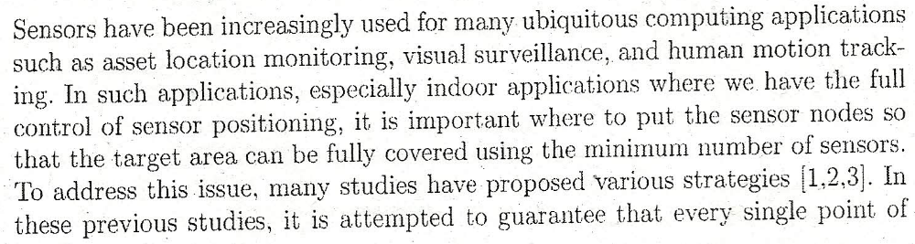
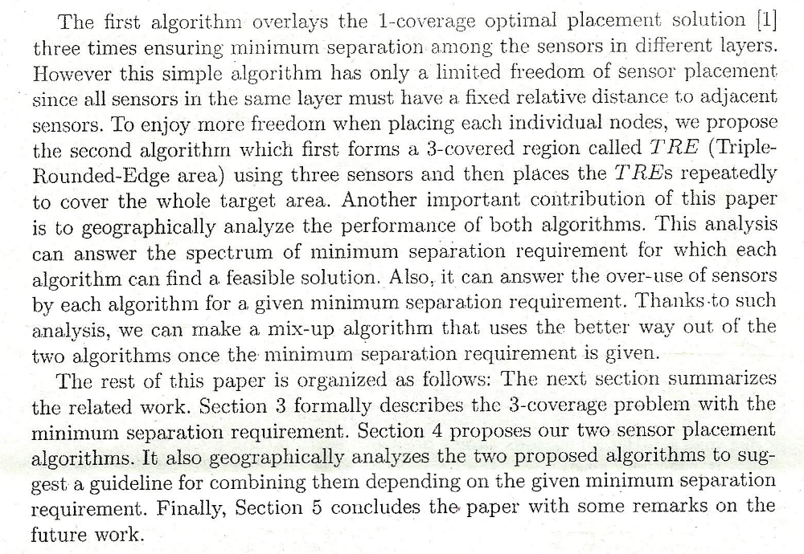

2.1.What is a Sensor?

- A sensor is a device that measures a physical quantity and converts it into a signal which can be read by an observer or by an instrument.
- A sensor is equipped with
  - A Transducer : It generates electrical signals based on sensed physical effects and phenomena.
  - A Microcomputer : It processes and stores the sensor output.
  - A Transceiver : It can be hardwired or wireless, receives commands from a central computer and transmits data to that computer.
  - A power source : The power for each sensor node is derived from the electric utility or from a battery.

- A good sensor obeys the following rules:
  - Is sensitive to the measured property
  - Is insensitive to any other property likely to be encountered in its application
  - Does not influence the measured property

2.2.What is Wireless Sensor Network?
A wireless sensor network (WSN) consists of spatially distributed autonomous sensors to monitor physical or environmental conditions, such as temperature, sounds, vibration, pressure, motion or pollutants and to cooperatively pass their data through the network to a main location.
A sensor network is a group of specialized transducers with a communication infrastructure intended to monitor and record conditions at diverse locations.
A sensor network consists of multiple detection stations called sensor nodes,each of which is small lightweight and portable.
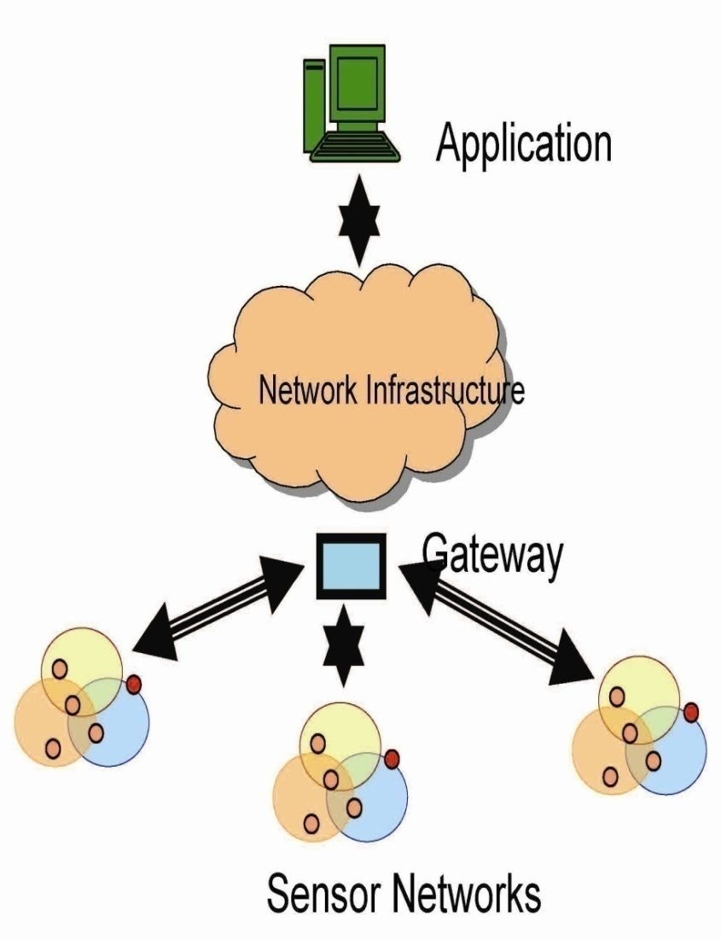

2.3.Some application of Wireless Sensor Network

- 1. Area monitoring
  - 1.1.Air pollution monitoring
  - 1.2 Forest fires detection
  - 1.3 Greenhouse monitoring
  - 1.4 Landslide detection
- 2 Industrial monitoring
  - 2.1 Machine health monitoring
- 3 Water/wastewater monitoring
  - 3.1 Landfill ground well level monitoring and pump counter
  - 3.2 Agriculture
- 4 Structural monitoring

2.4.Performance Metric of Wireless Sensor Network

- Coverage: For the surveillance kind of applications, the minimum k- coverage must be targeted for data accuracy and for sleeping nodes in an unreliable network, which allows node sleepings and failures. Instead of focusing on the minimum k-coverage, we test the relative frequency of exactly k-covered points using the k-coverage map of the network. Based on this, we measure the average k-coverage and the standard deviation of exactly k-covered points.

- Energy consumption: Since energy is the most critical issue in WSNs, it is necessary to optimize energy consumption in various ways. Using a proper node deployment scheme, energy consumption can be reduced
and can thus extend the lifetime of WSNs. We define a model which concerns the 1bit energy consumption of sensing, transmitting, and receiving for all nodes when communicating to their nearest sinks.

- Worst-case delay: Often the maximum allowable message transfer delay must be bounded in order to enable time-sensitive applications of WSNs. Using the foundation of sensor network calculus, we calculate the worst-case end-to-end delays for each flow and find the
.

3.1.What is Sensor Placement Problem?

- In Sensor Network it is important where to put the sensor nodes so that the target area can be fully covered using the minimum number of sensors. Every single point of target area must be sensed by at least one sensor.
- When placing sensor nodes another objective should be taken care of ,that is the minimum separation requirement . The sensor placed extremely close are likely to provide redundant information.

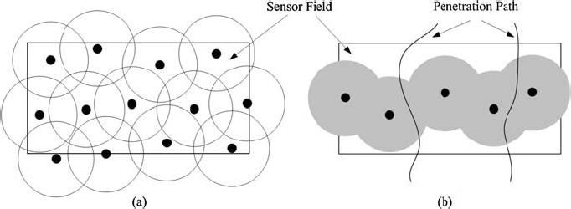

3.2.Why is it required to place the sensors appropriately?

Node placement is a fundamental issue to be solved in Wireless Sensor Networks (WSNs). A proper node deployment scheme can reduce the complexity of problems in WSNs as, for example, routing, data fusion, communication, etc. Furthermore, it can extend the lifetime of WSNs by minimizing energy consumption.
In distributed sensor networks (DSNs), the sensor placement due to cost limitation is currently one of the most important research issues. A sensor network can be deployed in two ways - with random placement or with grid-based placement. When the environment is unknown, random placement is the only choice and sensors may be thrown to any
place by aircrafts randomly. The alternative is to deploy sensors on a sensor field to guarantee a particular quality of service, if the properties of the terrain are predetermined.

4.1.Some terminologies

- We model the sensing coverage of a single sensor as a circle centered at the sensor position (x,y) with radius R, denoted by C(x,y,R)
- Size of C: Size(C)
- Size of Target Area: Size(TA)
- Size(TA)>> Size(C)

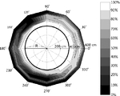

4.2.1-Coverage Optimal Solution Method

- Every point of target area is covered by one sensor.
- All the sensors are regularly placed with the same inter-sensor distance of √3R.
- Coverage redundancy(Algo1opt)=
(N*Size(C)-Size(TA))/Size(TA)=0.209
N=no. of sensors used in Algo1opt
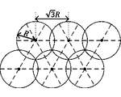
4.3. Why 1-coverage is not sufficient?
- Application like Triangulation-based tracking of moving objects. Wherever a target object moves in the target area, at least three distance sensors should be able to sense it to figure out its position through triangulation.
- Need to extend 1-coverage problem to general k-coverage problem, here specially 3-coverage problem. which is meaningful for many application.
4.4.Feasibility definition for 3-coverage sensor placement

- Feasibility Definition: A sensor placement solution is defined as feasible if and only if for every point (x,y) in TA there exist at least three sensors that can cover (x,y) and they are at least D_{min}^{req} apart from each other.
- Our problem is to,
Find a feasible sensor placement solution with the minimum number of sensors.

4.5.Performance metric for Sensor Placement Problem
- Coverage Redundancy : It reflects how much sensing coverage is unnecessarily overused compared to the ideal 3-coverage solution.
CoverageRedundancy(Algo)= (N_{Algo}*Size(C)-Size(TA)*3))/Size(TA)*3
- Feasible spectrum of D_{min}^{req} : It reflects the spectrum of for which Algorithm Algo can find a feasible solution. The wider is the spectrum, the more generally can Algo be used for various application.

5.1.Method 1: Overlaying method
Overlay carefully the 1-coverage placement three times with D_{min}^{req} across the three layers.

Step 1: For 1st layer,
- Just place the sensors as in 1-coverage.
- Connect the adjacent three sensors to form a equilateral triangle each side is √3R
Step 2: For 2nd layer,
- Start with a single sensor and place it at the centre of an equilateral triangle of 1st layer .
- Now place others following the rule of 1-coverage optimal placement.
Step 3: For 3rd layer,
- Place 3rd layer sensors at the centre of remaining equilateral triangle of 1st and 2nd layer .

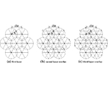
Analysis of Performance
Properties:
- If we place sensors using our overlaying method, each point of the target area is covered by atleast three sensors which are R apart.
- Then for this method,
D_{min}^{req} =R
Coverage redundancy(Overlay)=
(NO*Size(C)-Size(TA))
/Size(TA)
NO=no. of sensors used in Overlay
As NO=3*N from equation of 1-coverage
The coverage redundancy according to feasible D_{min}^{req} can be plotted as in the figure

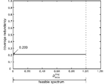

5.2.Why switch to Method 2?

- Although the overlaying method is simple and effective,it has a limited freedom of sensor placement.
- The Overlaying method has a freedom only at the level of controlling the fixed texture of the entire layer ,not individual sensor.
- Thus our 2nd method comes in this place to give us more freedom of controlling individual sensor position for the betterment in the coverage redundancy where D_{min}^{req} is small relative to the sensing range.

5.3.Method 2: TRE-Based Method
What isTRE(Tripple-Rounded-Edge area)?
- A 3-covered area
- An intersection of coverage
circles of 3 sensors equally
separated by distance d.
The lines connecting the centers of three circles form TRE Triangle.
Preference to small d,for big TRE,to make a large 3-covered area.
Any point in TRE is covered by 3 sensors.

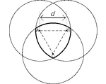

Process:
This method patches the TREs over the entire area to provide full 3-coverage.

Patching Process:
To minimize the overlap (to optimize coverage redundancy) among TREs we place them such that one rounded edge of one TRE just contacts the another TRE.

Distance between the centers of the two TRE triangles:
2*(R-(d/2)/ cos30º)

If we repeat this process 6 times then the 6th TRE just contacts the 1st TRE. This forms a hexagon, where six TREs are Outer TREs and one Inner TRE surrounded by them.

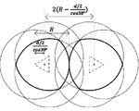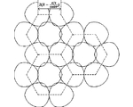
- There exists areas not covered by TREs, such areas can be covered by at least three TREs when d is larger than a threshold, denoted by d_{min} .
- As decreasing d, the three circles forming each TRE start collapsing to one circle, at some point the circles meet at a point.
- The centre of circles (x,y) are known as function of d.
- Value of d_{min} =0.196R
- if d>= d_{min} the entire target area is fully 3 –covered without any hole.

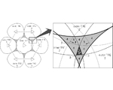
- The sensors of two different TRE are d apart(d-separation), d<=0.6R
When d= d_{min} =0.196R> D_{min}^{req} then,
d-separation= D_{min}^{req} –separation
When D_{min}^{req} is in the range
(0.196R,0.6R) then, d= D_{min}^{req}
Thus d=max(d_{min}, D_{min}^{req})

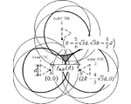

Analysis of Performance
- In this method for each hexagon the coverage redundancy is the same.
CoverageReduandancy(TRE)=
(NT*Size(C)-Size(TA)*3)/Size(TA)*3
=(NT(hexagon)*Size(C)-Size(hexagon)*3)/Size(hexagon)*3
NT=No. of Sensors used in this method.
Length of each side of the hexagon=2*(R-d/2/cos30º)
Area of the hexagon=
√3/4(2*(R-d/2/cos30º)*6

So,
CoverageRedundancy(TRE)=
(9*πR²-(√3/4(2*(R-d/2/cos30º))²*6)*3)
______________________________
(√3/4(2*(R-d/2/cos30º))²*6)*3

Since we use d=dmin=0.196R until D_{min}^{req} reaches dmin=0.196R and then we us d= D_{min}^{req} afterwards

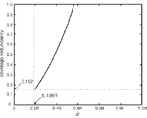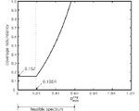

5.4.Comparision study of these two methods
- TRE –Based method gives better coverage redundancy than Overlaying method when D_{min}^{req} <=0.232R
- E.g. Cricket distance sensors for localizing objects in a ubiquitous system,
D_{min}^{req} =20cm
R=320cm
D_{min}^{req} =0.0625R
Suggested Method:TRE-Based Method.

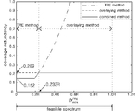

6.CONCLUSION

- Thus in many Sensing Application, every target point needs to be sensed by more than one sensor separated by at least a certain distance, for us to extract useful information of the domain.
  - Then the first point arises is appropriate coverage of each point on Target Area,so that we may not miss any useful information or as well as no redundancy.
  - The second point,the minimum separation of the sensors are required so that not a single point is made out of coverage.

7.References
- 1.1.Sensor Placement for 3-Coverage with Minimum Separation Requirement
By Jung-Eun Kim, Man-Ki Yoon, Junghee Han, and Chang-Gun Lee

- 1.2. Node Deployment in Large Wireless Sensor Networks:
Coverage, Energy Consumption, and Worst-Case Delay
By Wint Yi Poe & Jens B. Schmit
Disco | Distributed Computer Systems Lab
University of Kaiserslautern, Germany
poe@informatik.uni-kl.de

Abstract:
Node deployment is a fundamental issue to be solved in Wireless Sensor Networks (WSNs). A proper node deployment scheme can reduce the complexity of problems in
WSNs as, for example, routing, data fusion, communication,etc. Furthermore, it can extend the lifetime of WSNs by minimizing energy consumption. In this paper, we investigate random and deterministic node deployments for large-scale WSNs under the following performance metrics: coverage, energy consumption, and message transfer delay. We consider three competitors: a uniform random, a square grid, and a pattern-based Tri-Hexagon Tiling (THT) node deployment. A simple energy model is formulated to study energy consumption for each deployment strategy. Using basic geometry we propose a novel strategy for calculating the relative frequency of exactly k-covered points, which uses k-coverage maps, for both a square grid and THT. To model and consequently control the worst-case delay of a given WSN we build upon the so-called sensor network calculus (a recent methodology introduced in [7]). Finally,we analyze tradeoffs between these performance metrics for each deployment strategy to show which strategy is preferable under what factors, e.g., the number of nodes.

- A Near-Optimal Sensor Placement Algorithm to
Achieve Complete Coverage/Discrimination in
Sensor Networks
Frank Y. S. Lin and P. L. Chiu, Student Member, IEEE

From Introduction(I)

8.Related Works

- Energy-Efficient Target Coverage in Wireless
Sensor Networks Based on Modified Ant Colony
Algorithm
1Salma Begum, 2Nazma Tara, 3Sharmin Sultana,
Department of Computer Science & Engineering, University of Dhaka, Dhaka,
Bangladesh
1jennycsdu@yahoo.com, 2taranaz2003@yahoo.com, 3jui_sharmin@yahoo.com,

- Distributed Deployment Schemes for Mobile Wireless Sensor Networks to Ensure Multilevel Coverage

You-Chiun Wang Yu-Chee Tseng
Dept. of Comput. Sci., Nat. Chiao Tung Univ., Hsinchu

